

College of Engineering, Environment, and Computing
School of Science

MSc in Data Science and Computational Intelligence
7151CEM Computing Individual Research Project

Project Report

Bankruptcy Prediction using Financial Ratio

By

Shreyas Srikanth
SID: 15603814

1st Supervisor: Kamal Bentahar
2nd Supervisor: Beate Grawemeyer

Submitted in partial fulfilment of the requirements for the Degree of Master of Science in Data Science and Computational Intelligence

Academic Year: 2025/26

Declaration of Originality
I declare that this project is all my own work and has not been copied in part or in whole from any other source except where duly acknowledged. As such, all use of previously published work (from books, journals, magazines, internet etc.) has been acknowledged by citation within the main report to an item in the References or Bibliography lists. I also agree that an electronic copy of this project may be stored and used for the purposes of plagiarism prevention and detection.
Statement of copyright
I acknowledge that the copyright of this project report, and any product developed as part of the project, belong to Coventry University. Support, including funding, is available to commercialise products and services developed by staff and students. Any revenue that is generated is split with the inventor/s of the product or service. For further information please see www.coventry.ac.uk/ipr or contact ipr@coventry.ac.uk.
Statement of ethical engagement
I declare that a proposal for this project has been submitted to the Coventry University ethics monitoring website (https://ethics.coventry.ac.uk/) and that the application number is listed below (Note: Projects without an ethical application number will be rejected for marking)

Signed: Shreyas Srikanth Date: 02/12/2025
Please complete all fields.

First Name: | Shreyas
Last Name: | Srikanth
Student ID number | 15603814
Ethics Application Number | P189396
1st Supervisor Name | Kamal Bentahar
2nd Supervisor Name | Beate Grawemeyer
This form must be completed, scanned and included with your project submission to Turnitin. Failure to append these declarations may result in your project being rejected for marking.

Abstract
Most companies do not go bankrupt overnight; in fact, most companies had been showing signs of financial difficulty prior to filing for bankruptcy. By identifying these signs early on, investors, lenders and regulators will be able to make better decisions regarding companies that may ultimately go bankrupt. Traditionally, there have been models available to in the market for predicting company bankruptcy such as Beaver's ratio analysis model, Altman's Z-Score and Ohlson's O-Score. However, these traditional methods have limitations which make them challenging to apply on larger, more complex datasets associated with companies today.
The goal of this project was to create a machine learning based approach to predicting financial distress using U.S. SEC FSDS datasets. The datasets comprised of 124,409 company financial filings (annual & quarterly) from 2020-2024. After the numerical data was cleaned, converted and standardised, over 20 meaningful financial ratios were created for assessing liquidity, leverage, profitability, efficiency, and the core components of Altman's Z-Score. In addition, a simple rule was created to identify distressed firms via a negative stockholders' equity.
There were five models examined in this study, which were Random Forest, XGBoost, Logistic Regression, Multi-Layer Perceptron and Deep Neural Network. Based on an Accuracy of 0.743 and AUC of 0.812, XGBoost provided the best overall results when compared to all four other models. Further to this, XGBoost achieved very similar accuracies (ranging from 0.72 to 0.75) during each of the testing periods. In addition, the use of SHAP techniques allowed us to see what ratios all five models used to determine their predictions. Finally, a Robustness Analysis confirmed that each of the five models could withstand minor numerical perturbations.
The final product from Project is a scalable, easily interpreted process for predicting bankruptcy based on SEC data from the stock market.

Table of Contents

Abstract 2
Table of Contents 3
Acknowledgements 4
1 Introduction and Objectives 5
2 Literature Review 7
3 Methodology 9
4 Project Management 18
4.1 Project Schedule 18
4.2 Risk Management 18
4.3 Quality Management 19
4.4 Social, Legal, Ethical and Professional Considerations 20
5 Critical Appraisal 21
6 Conclusions 23
6.1 Achievements 23
6.2 Future Work 24
7 Student Reflections 26
Bibliography and References 27
Appendix A – Certificate of Ethics Approval 1
Appendix B – Weekly Meetings 1
Appendix C – GitHub Link and Word Count 1

Acknowledgements
I would like to express my sincere gratitude to the College of Engineering, Environment and Computing, and the School of Science at Coventry University for providing the academic environment, resources, and institutional support that enabled me to carry out this research project as part of the MSc in Data Science and Computational Intelligence. The facilities, teaching quality, and structured learning framework offered by the University have played a crucial role in shaping my development as a postgraduate student and a data science practitioner.
I am deeply thankful to my first supervisor, Dr. Kamal Bentahar, for his continuous guidance, constructive feedback, and academic direction throughout every stage of this project. His expertise in artificial intelligence, machine learning, and research methodology has been invaluable in informing the design, implementation, and evaluation of the predictive models developed in this dissertation. His patient mentorship and ability to provide clarity during complex phases of the research significantly strengthened both my technical understanding and the overall quality of the work.
I would also like to extend my sincere appreciation to my second supervisor, Dr. Beate Grawemeyer, for her thoughtful insights, supportive discussions, and consistent encouragement throughout the project period. Her feedback challenged me to think critically, refine my approach, and enhance the clarity and presentation of my results. Her support has contributed greatly to my academic growth and confidence as an independent researcher.
My thanks also go to the module team of 7151CEM – Computing Individual Research Project, whose detailed guidance, module documentation, and structured milestones ensured that I remained focused and organised throughout the research process. Their commitment to student success, coupled with timely communication and accessible resources, played a fundamental role in helping me meet the academic standards required for this dissertation.
I am equally grateful to my classmates and peers within the MSc programme, who created a collaborative and motivating learning environment. Our shared discussions, problem-solving sessions, and mutual encouragement made the challenging aspects of this work more manageable and rewarding.
Finally, I owe special gratitude to my family and friends for their endless support, patience, and belief in my abilities. Their encouragement kept me grounded and motivated, especially during demanding stages such as data preparation, extensive modelling, and writing. Without their understanding and support, completing this dissertation would not have been possible.

1 Introduction and Objectives

1.1 Background to the Project
The Event of Corporate Bankruptcy is a crucial financial occurrence with the potential of disrupting an entire industry, impacting tens of thousands of employees, and causing notable losses to investors and creditors. Providing earlier warnings for this type of event can enhance financial planning, risk management, and the development of regulations pertaining to corporate bankruptcy events. Historically, the prediction of corporate bankruptcy events has relied on various statistical models such as Beaver's Univariate Analysis, Altman's Z-Score, and Ohlson's Logistic Regression to assist with identifying the impact and importance of financial ratios. However, the predictive accuracy of historical statistical models is very limited due to the strict assumptions made by most financial models, such as Linearity and Normality. In addition, current day corporations function in densely leveraged, quick-moving, and highly complex environments and, therefore, historical models are insufficient for accurately predicting corporate bankruptcy events.
Recent advances in computer science (data science) and computational intelligence have helped to provide additional sources of data for the trainer of a bankruptcy prediction tool, as well as flexible models that are better suited for analysing financial risk in a more thorough manner. Machine Learning (ML) techniques are able to model the complex, nonlinear relationships that comprise financial data, including Random Forests, XGBoost, and Neural Networks. However, most studies conducted to date rely on small datasets from specific industries only, with simplified inputs or otherwise non-interpretive models. The availability of large-scale real-world datasets from the U.S. Securities and Exchange Commission (SEC) is not widely leveraged within the bankruptcy prediction arena and currently there are very few studies that incorporate a full end-to-end system into the development of a bankruptcy prediction model.
The SEC Financial Statement Data Sets (FSDS) have collected thousands of filings of Annual (10-K) and quarterly (10-Q) returns. The FSDS provide a complete history of firm performance, but they are difficult to analyze due to the presence of multiple, inconsistent, and cluttered numeric fields that must be pre-processed before any useful data analyses can be done. As a result, many researchers have been discouraged from using the FSDS in their prediction studies; therefore, this area of research has been severely underrepresented in the existing literature. This gap has left researchers lacking a reliable and valid, large-scale, numeric bankruptcy prediction model based on actual SEC filings.
The purpose of this project is to fill this void by creating an organized dataset based on SEC Filing data from 2020 through 2024, to engineer financial ratios representative of the financial status of corporations, and to use machine learning and deep learning algorithms to develop predictive models for distressed firms. The proposed project will also utilize the explainable AI tools SHAP values to identify the financial ratios that are most influential in the prediction models; this is critical for finance professionals to make informed financing decisions.

1.2 Problem Statement and Research Gap
In bankruptcy prediction several critical gaps exist despite decades of academic work
- Many studies have focused on small, country-specific datasets that lacks generalisability.
- Numeric-only SEC datasets are rarely used because of their complexity
- Few studies provide a full end-to-end pipeline from raw SEC data → ratios → models.
- Robustness testing (e.g., noise sensitivity) is rarely explored.
- Many ML models lack explainability i.e. which financial ratio is driving the bankruptcy.
By directly addressing these gaps by computing a comprehensive set of financial ratios on SEC-based dataset implementing ML/DL models, performing robustness evaluation and explainability techniques.’

1.3 Project Objectives
The primary aim of this project is to develop a scalable, interpretable bankruptcy models using financial ratios derived from SEC filings. Some of the main objectives are as follows:

1.3.1 Analyse and model the requirements
This includes:
- Identifying relevant SEC filings and accounting line items.
- Determining which financial ratios align with bankruptcy prediction theory.
- Defining an appropriate target variable for distress (e.g., negative equity).
- Understanding class imbalance and dataset composition.
- Selecting evaluation metrics such as Accuracy, F1, and ROC-AUC.
- Ensuring the final system meets both academic and real-world relevance.

1.3.2 Investigate possible solutions
This objective focuses on selecting and evaluating:
- Machine Learning algorithms: Logistic Regression, Random Forest, XGBoost
- Neural Network approaches: MLP and Deep Neural Networks
- Feature engineering techniques for ratios and Altman Z-score components
- Explainability methods such as SHAP
- Robustness testing approaches to ensure reliable predictions
The goal is to produce a model that is accurate, reliable, interpretable, and robust, suitable for financial risk assessment.

1.4 Overview of This Report
This report consists of several different sections:
- The Literature Review – summarises the current body of knowledge about bankruptcy prediction in addition, it identifies both the strengths and weaknesses of traditional and machine learning methods as they relate to bankruptcy prediction.
- The methodology describes how data was collected, refined, created, developed into a model, and evaluated to achieve this project’s objectives.
- The Project Management section describes the elements of scheduling, risk management, and assuring the quality of the project’s deliverables.
- The Critical Appraisal section documents the challenges encountered and identifies the limitations of this project.
- Finally, the Conclusions and Future Work section provides a summary of the most significant findings and presents recommendations for expanding the project to include textual data, the development of time-series models, and the creation of a more sophisticated evaluation framework.

2 Literature Review
The development of bankruptcy prediction research has moved from a statistical foundation to a large focus on Machine Learning and Deep Learning. Studies that were done earlier, such as Beaver (1966), Altman (1968), and Ohlson (1980), showed the important role accounting ratios such as Liquidity, Leverage and Profitability play in predicting financial distress. These traditional bankruptcy prediction methods were useful in establishing predictor variables but were limited in their ability to capture the dynamics of modern financial data by employing linear modelling assumptions and simplistic functional relationships.
Recent work focuses on the use of machine learning to address the limitations of traditional bankruptcy prediction techniques. Tran, Nguyen, and Vo (2023), for example, used ensemble methods to analyse Vietnamese publicly listed companies and found that the Random Forests and Gradient Boosting algorithms provided superior predictive performance compared to logistic regression and discriminant analysis. Lee and Li (2022), also tested a wide range of machine learning methods on bankruptcy data from Taiwan and found that the machine learning models based on Boosting had the highest levels of predictive accuracy, even when using a small number of financial features. The overall conclusion from these works is that machine learning techniques for bankruptcy prediction provide improved non-linear modelling capabilities and greater robustness when the input data is noisy or imbalanced.
A recent trend also shows that textual data has become an integral part of predictive modelling. In studying the Management Discussion & Analysis section of SEC 10-K reports, Kim and his colleagues showed that using textual indicators like uncertainty, tone and future orientation significantly improves predictions of bankruptcy when combined with numerical indicators. They also demonstrated the necessity of performing sensitivity analysis to examine how changing or omitting critical textual indicators impacts a prediction outcome from the bankruptcy prediction model. As a follow-up of that research, Chen and Huang developed a method where sentiment-weighted textual embeddings are combined with financial ratios. This methodology resulted in greater accuracy in bankruptcy prediction than either numerical only or textual only models. These studies demonstrate that the narratives presented in financial statements are often strong indicators of an organisation's potential for financial failure.
Computational models have continued to evolve, with the introduction of more sophisticated models. An example of an advanced computational model is that of Qian et al. (2023), the QTIAH-GNN, a graph neural network that integrates multiple types of inputs: financial indicators, inter-firm relationships, as well as textual data. Qian et al. found that by using a corporate network approach, class imbalance was lessened, which increased predictive accuracy in extreme instances. Nevertheless, the extra demands placed on computational resources and the very large amount of data that must be processed to train the model make it extremely difficult to implement in practice on large, multi-year datasets like the SEC Financial Statement Data Sets (FSDS). Wang and Chen (2022) investigated the performance trend of firms across multiple years using LSTM-based temporal models. Although temporal modelling enhances the accuracy of the model, Wang and Chen found that their model was sensitive to both periods of missing data and variations in the reporting cycles of firms.
While these advancements have progressed, many limitations exist within the body of literature now. Empirical research concludes many of the smaller or regional datasets, in many cases containing thousands of observations only which leads to high concern regarding their ability to generalise findings across populations and their lack of external validity. For example, studies utilising US SEC data will often study only short time spans or specific subsets of firms, thus reducing the robustness of their findings. In addition, while machine learning models have shown strong performance, interpretability is often left out. Only a limited number of papers incorporate tools for explainability, such as SHAP or neural attention maps, behavioural prediction within a finance domain is high stakes; decision processes must be transparent to be effective. Evaluating robustness, through methods such as noise sensitivity testing or adversarial perturbation testing, is seldom conducted, but is necessary for real-world use.
Similarly, there are no thorough numerical Benchmarking Studies constructed from Raw FSDS SEC Data over Large-Scale datasets. While hybrid textual-numeric model applications are growing in popularity, very few academics report comparative benchmarks by only utilising Structured Financial Filings Data and by utilising high-quality Structured Financial Ratios in their data preparation. Most academics that have published numeric-only studies have adopted only Simplified methodologies or limited to a limited number of ratio sets causing an undisputed gap in the methodology being employed in the set of studies.
The project focuses on ending the current gaps in bankruptcy data by creating one of the largest bankruptcy datasets based on SEC FSDS (2020-2024) through a thorough data-cleaning process, calculating over twenty financial ratios (including those used for Altman Z score), and comparing multiple machine learning and deep learning methods. This work will also incorporate SHAP based explainability and the evaluation of robustness testing using noise perturbation methods; neither of which have been used together in prior studies. This creates a numerical benchmark which is transparent, reproducible, and scalable to all existing academic research on bankruptcy.

3 Methodology

Utilizing a systematic, data-oriented approach, the proposed project will create a predictive model for bankruptcy on a numeric basis via financial statement data obtained from the SEC Financial Statements Data Sets (FSDS), creating a scalable, interpretable, and robust outcome. The systematic approach to the bankruptcy prediction model has six distinct stages: acquire data; clean data; generate new variables (features); explore data; develop models, create explanations for model outcomes; evaluate the robustness of the outcome. All six stages utilize standard methods in the fields of data science and computational intelligence. However, each has been individually developed and adapted to account for the specific issues associated with financial statements, e.g., missing values, exponentially high or exponentially low values, inconsistent data structures, class imbalance problems.

3.1 Data Acquisition
The FSDS files, which provide information on millions of raw numeric accounting line items sourced from annual (10-K) and quarterly (10-Q) Filings, can be downloaded from the SEC's website for the years 2020 through 2024. For this project, the only filings that are included in the dataset were those that had been designated under the classification of Forms: 10-K, 10-K/A, 10-Q, and 10-Q/A.
The files were respective to one another and therefore were merged into one file for ease of use and later processing, resulting in a dataset with 124,409 filings to begin with before cleaning up any inconsistencies. As this dataset is substantially larger and represents significantly greater variety than that which has been used in many previously developed bankruptcy predictive models, it permits more generalized results.

3.2 Data Cleaning and Preprocessing
Because it is common for there to be inconsistencies between financial statement datasets due to inconsistencies in reporting standards and missing information as well as extreme values, it was necessary to have produced a high degree of rigor within the cleaning pipeline.

3.2.1 Conversion and Standardisation
To ensure that the numerical values contained within all accounting categories (i.e. Assets; Liability; Revenues) are represented as floating point (decimal) numbers, to provide mathematical consistency. In addition, duplicate entries within each filing were eliminated by use of a unique filing identifier adsh.

3.2.2 Handling Missing Values
Initially the analysis demonstrated a substantial number of missing values for certain features such as SalesRevenueNet, Inventory Net. To preserve data integrity, a set of core required fields was defined:
- Assets
- Liabilities
- Assets Current
- Liabilities Current
- Revenues
- Net Income Loss
Any records missing any of these essential items were dropped. This reduced the dataset to 12,673 high-quality filings, forming the foundation for ratio computation.
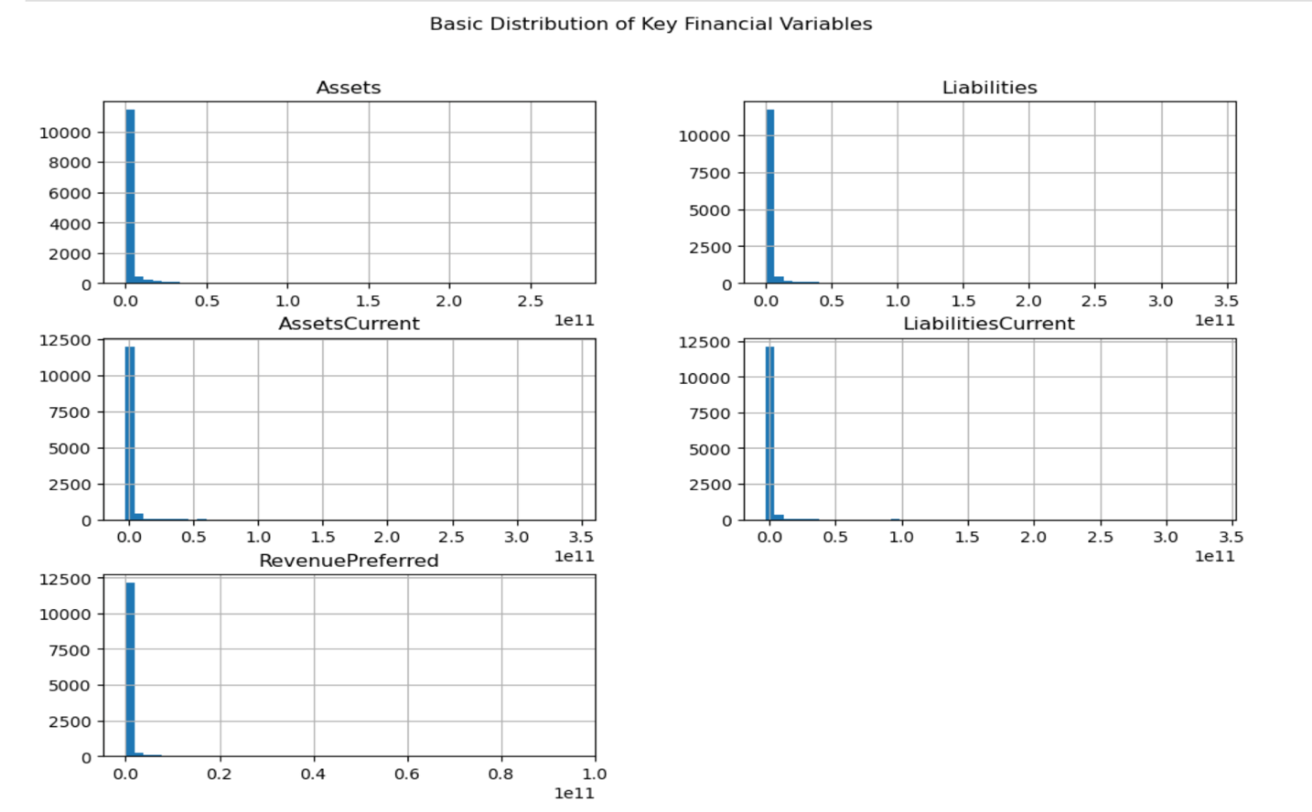
Figure 1: “Basic Distribution of Key Financial Variables”
This bar chart illustrates the proportion of filings labelled as non-distressed (70.3%) and distressed (29.7%) based on the Stockholder Equity < 0 criterion. The distribution shows a moderate class imbalance, which was addressed using class weighting during model training

3.2.3 Invalid and Impossible Values
Financial statements containing anomalies such as negative assets, liabilities were deleted and infinite values that were encountered during division in ratio calculations were replaced with NaN and subsequently handled.

3.2.4 Outlier Treatment
Extreme outlier values were expected given the scale of SEC financial data which were visualised using Box Plot.
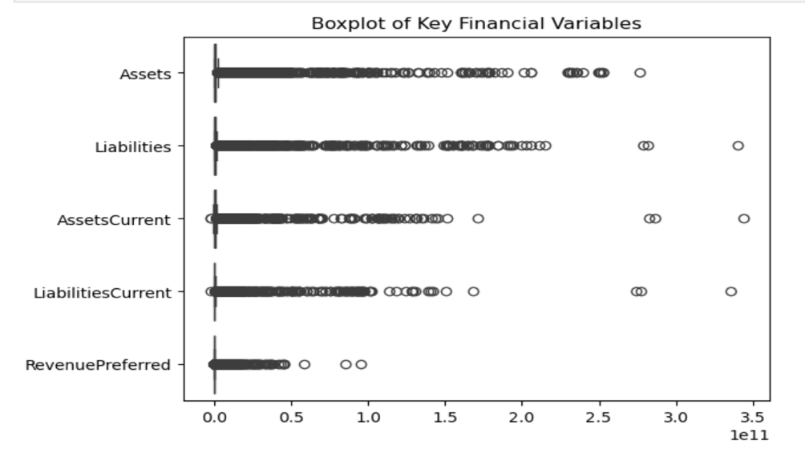
Figure 2: “Boxplot of Key Financial Variables”
This Figure demonstrated severe skewness in large-scale variables. A mild winsorisation of 1% on both tails was therefore applied to prevent distortion during model training.

3.2.5 Log Transformations
Large numerical variables such as Assets, Liabilities, Revenues, RevenuePreferred exhibited heavy right-skew, which sometimes leads to degradation of model performance. Natural log transformations were applied to stabilise the variance.
- log_Assets
- log_Liabilities
- log_Revenues
- log_RevenuePreferred
These transformed variables became the most important predictors in SHAP analysis.

3.3 Target Variable Construction (Bankruptcy Labelling)
Bankruptcy was defined based on a financially meaningful threshold:
Healthy | Stockholder Equity ≥ 0
Distressed (Bankrupt) | Stockholder Equity < 0
Table 1 – “Target Variable Construiction”
This aligns with long-standing financial theory: negative equity indicates liabilities exceeding assets a common precursor to insolvency.
The resulting distribution was:
Class | Count | Percentage
Non-Distressed (0) | 8,910 | 70.3%
Distressed (1) | 3,763 | 29.7%
Table 2 – “Class Distribution”
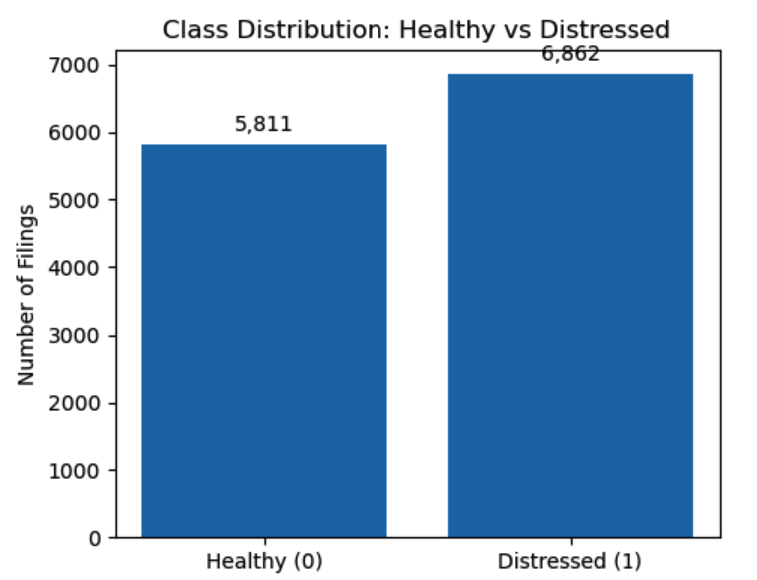
Figure 3: “Class Distribution”
This figure visualises the spread and presence of extreme outliers in major financial fields. The elongated whiskers and numerous extreme points confirm heavy-tailed distributions typical of SEC datasets, motivating later scaling and robust modelling decisions.
3.4 Feature Engineering
To convert raw accounting values into meaningful financial signals, the following ratios were engineered. These represent key liquidity, leverage, profitability, and efficiency dimensions used in academic bankruptcy literature.

Category | Ratios
Liquidity | Current Ratio, Quick Ratio, Working Capital
Leverage | Debt Ratio, Equity Ratio, Liability-to-Asset Ratio
Profitability | Net Margin, Operating Margin, Return on Assets
Efficiency | Sales/Total Assets, Inventory/Assets
Altman Z Components | WC/TA, RE/TA, EBIT/TA, Sales/TA, ME/TL
Other Engineered Features | log-transformed variables
Table 3 – “Financial Ratios Computed”
Each ratio was evaluated visually through distribution plots:
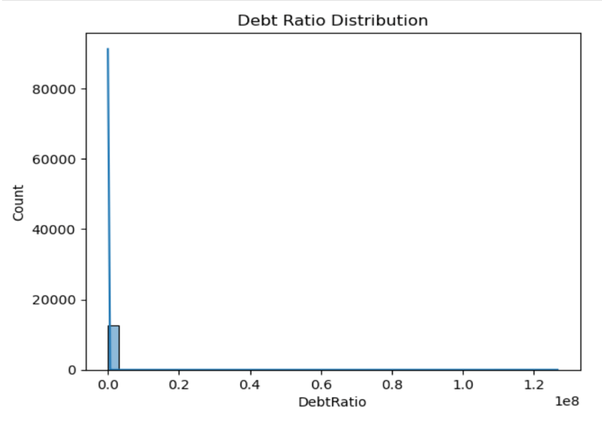
Figure 4: “Debt-Ratio Distribution”
This histogram summarises the Debt Ratio (Liabilities / Assets). Most firms cluster around modest debt levels, while a minority exhibit extreme leverage. High Debt Ratio values later emerge as key distress indicators in SHAP analysis.

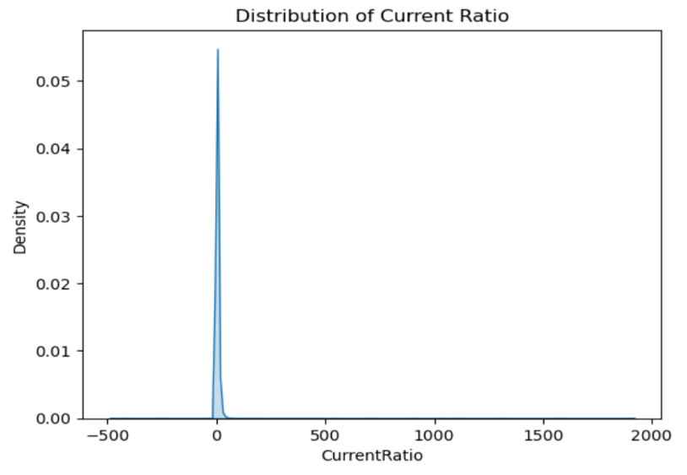
Figure 5: “Distribution of Current Ratio”
This kernel density plot shows the distribution of the Current Ratio (AssetsCurrent / LiabilitiesCurrent). Most values cluster between 0 and 10, with a long tail of unusually high ratios. This supports the decision to apply winsorisation to reduce disproportionate influence from extreme liquidity values.

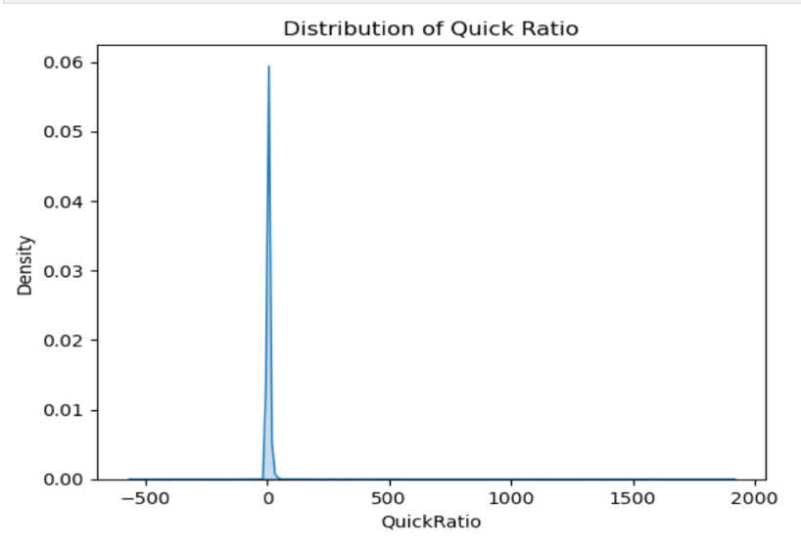
Figure 6: “Distribution of Quick Ratio”
This density plot represents the Quick Ratio distribution. Similar to the Current Ratio, it presents heavy skewness and sporadic extreme values, reinforcing the necessity of outlier handling before model training.

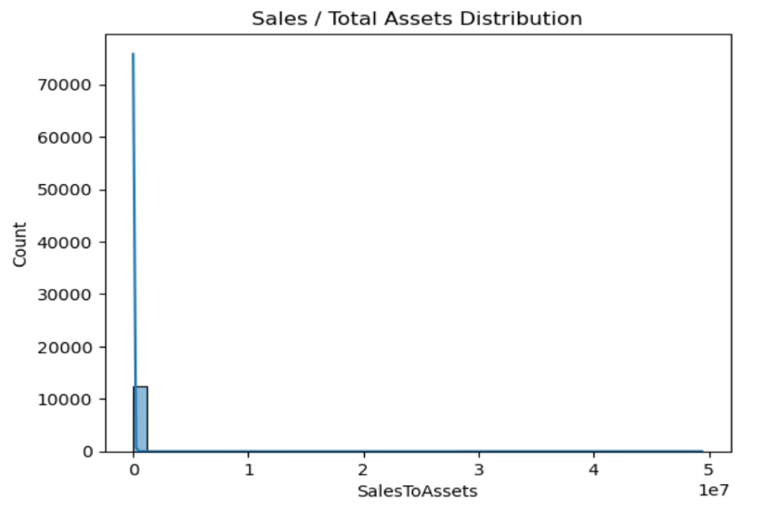
Figure 7: “Sales / Total Assets Distribution”
This histogram captures the distribution of efficiency (Sales divided by Total Assets). The plot demonstrates that most firms generate moderate asset productivity, with rare but significant extreme cases. This ratio later contributes to Altman Z-score components.

3.5 Exploratory Data Analysis (EDA)
EDA was performed to understand interaction patterns between ratios.

3.5.1 Correlation Analysis
A heatmap was generated to reveal multicollinearity:
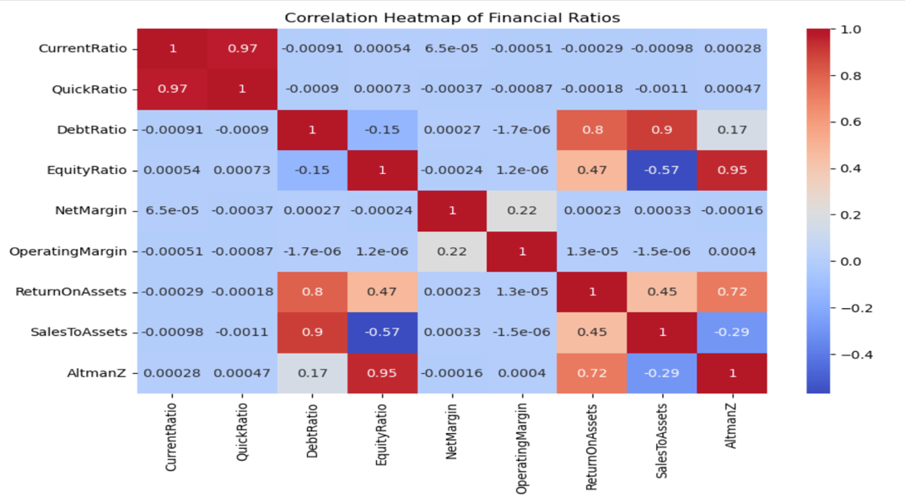
Figure 8: “Correlation Plot”
The heatmap displays pairwise correlations across engineered ratios and log-transformed variables. It highlights meaningful relationships—e.g., strong positive correlation between Assets and Revenues, and negative correlation between Equity Ratio and Debt Ratio. This analysis guided model selection, particularly why tree-based models performed well.
Key findings:
- Strong positive correlations between Assets, Revenues, and Liabilities
- Expected negative correlation between Equity Ratio and Debt Ratio
- Moderate dependencies within Altman Z-score components

3.5.2 Structural Relationship Check
A simple scatter comparison between Assets and Liabilities was plotted:
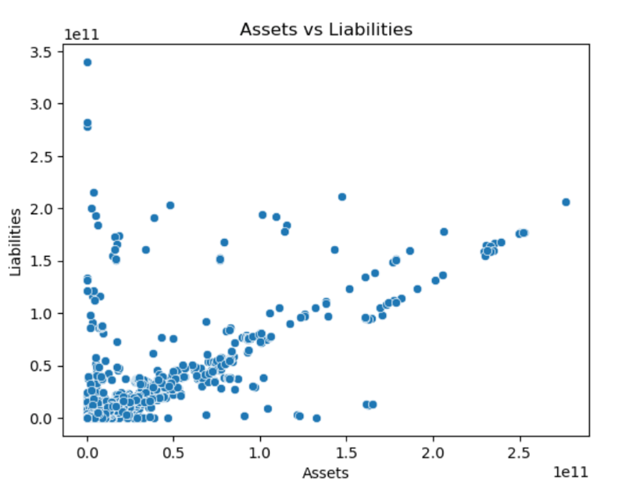
Figure 9: “Assets v/s Liabilities”
This plot visualises the relationship between total Assets and Liabilities. The strong positive linear pattern confirms expected financial structure behaviour. Outliers deviating from the trend indicate highly leveraged or unusually structured firms, justifying their treatment during robustness testing.

3.6 Train–Test Split and Scaling
An 80/20 stratified split preserved class proportions. Scaling was applied using StandardScaler for models sensitive to feature magnitude (Logistic Regression, MLP, DNN). Tree-based models (RF, XGBoost) used raw scaled ratios.

3.7 Machine Learning and Deep Learning Models
Five models were implemented to provide comprehensive benchmarking:
Model | Functionality | Accuracy | AUC Curve
Logistic Regression | interpretable baseline | 0.726 | 0.772
Random Forest | non-linear ensemble, handles feature interactions | ~0.74 | ~0.79
XGBoost | gradient boosting, best performance | 0.743 | 0.812
MLP Neural Network | learns non-linear relationships | 0.741 | 0.79
Deep Neural Network (DNN) | deeper architecture with dropout + batchnorm | 0.740 | 0.79
Table 4 – “ML/DL Models”
Class imbalance was handled via class_weight = “balanced” for all models.

3.8 Model Evaluation

Metrics Used
- Accuracy
- Precision, Recall, F1-score
- ROC-AUC (primary metric)
A composite ROC Curve visual was generated:
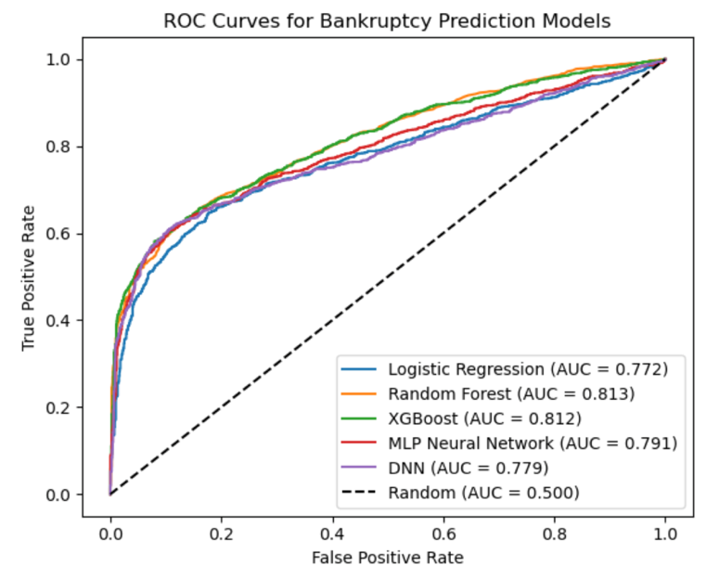
Figure 10: “AUC Plot”
This plot compares all modelled classifiers in a single evaluation space.

3.9 Explainability Using SHAP
SHAP values were used to interpret XGBoost, the strongest ML model. This technique decomposes each prediction into additive contributions of each feature.
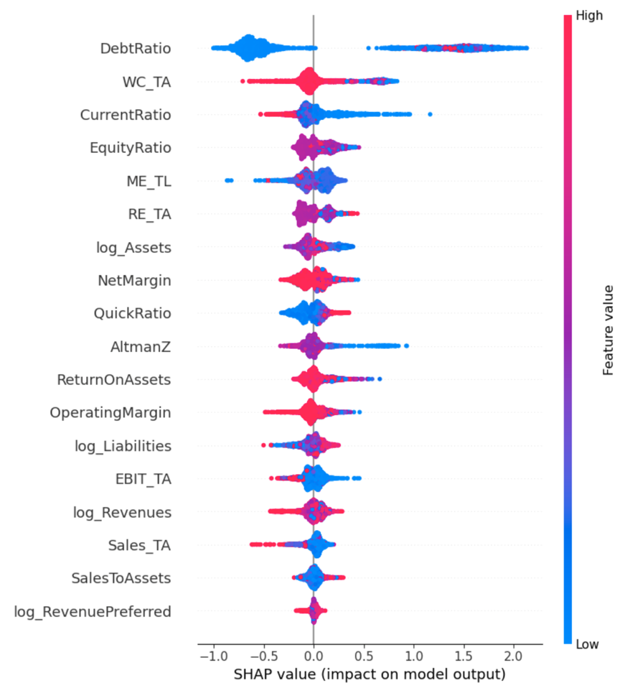
Figure 11: “SHAP Diagram”
Key insights:
- Debt Ratio, WC/TA, and Equity Ratio had the highest influence
- log-transformed features strongly contributed, validating preprocessing decisions
- High leverage and poor profitability consistently pushed the model toward predicting “distress”
SHAP analysis addressed the literature gap around model interpretability and allowed financial rationale to accompany model decisions.

3.10 Robustness Evaluation
Robustness was tested by adding controlled Gaussian noise to the input features and evaluating prediction stability. The resulting Robustness Score quantified sensitivity:
Robustness Score = 0.02036 (lower = better)
This indicates that the model remains stable under reasonable perturbations—important in volatile financial environments.

Summary of Methodology
The methodology combined strict financial preprocessing, statistically grounded feature engineering, balanced ML and DL models, and state-of-the-art interpretability tools. This supports both academic credibility and practical usability for financial risk assessment.

4 Project Management
In order to create an end-to-end Bankruptcy Prediction System using SEC financial data, effective project management was essential to coordinate the wide range of technical, analytical, and documentation activities involved. Each stage of the project—data collection, cleaning, feature engineering, model development, evaluation, and reporting—required careful planning to ensure consistent progress and avoid delays. This section outlines how the project was scheduled, how potential risks were identified, monitored, and mitigated, and what quality assurance practices were followed to maintain accuracy, reproducibility, and clarity.
Throughout the project, ethical and professional considerations were also prioritised, particularly with regard to transparency, responsible use of publicly available financial data, and adherence to academic standards. The project was managed using a structured yet flexible approach, allowing adjustments to be made as new insights emerged or challenges arose. Regular meetings with the supervisor provided ongoing guidance and helped refine decisions at each development stage. By using iterative development cycles—each producing a tangible work product—the project remained organised while still allowing room for exploration and continuous improvement.
4.1. Project Schedule
The Project followed a phased schedule based on a simplified Work Breakdown Structure (WBS); Work was segmented into the following major components:
- Data Acquisition and Understanding (Weeks 1-2)
Downloading and reviewing the SEC FSDS data (10-K and 10-Q filings) and reviewing the variable definition documentation to identify which of the Accounting Tags will be required for Feature Engineering.
- Data Cleaning and Preprocessing (Weeks 3-4)
Converting the Numeric Data Fields into Standardized Formats; Removing Invalid Entries (for example, Negative Assets); Addressing Missing Values; Winsorizing outliers; and Applying Log Transformations. Due to the complexity and inconsistency in the actual filings provided by S.E.C; multiple passes through this step were required before the data could be considered complete and ready for Feature Engineering
- Feature Engineering and Ratio Development (Weeks 4-6)
Calculating Liquidity, Leverage, Profitability, Efficiency Ratios and the components required to calculate an Altman's Z-Score. To accurately calculate these ratios, several iterations of the calculations were required as the calculations were Debugged.
- Model development and evaluation (Weeks 7–8)
Training Logistic Regression, Random Forest, XGBoost, MLP, and DNN models; addressing class imbalance; performing hyperparameter tuning; generating ROC-AUC comparisons.
- Explainability and robustness testing (Weeks 8–9)
Generating SHAP value visualisations and performing adversarial robustness testing by injecting noise into key variables.
- Documentation and report writing (Weeks 10–12)
The literature review, methodology, project management, critical appraisal, and conclusion sections are drafted. Along with tables and plots integrated, drafts were revised from supervisors based on feedback.
Although initially drafted a Gantt chart-style project plan was modified as needed. The most significant delays in project initiation occurred early in the preprocessing stage because of an inconsistency in the level of cleaning required for SEC data. To ensure the ratios were accurate before creating datasets using the pre-processed SEC data required an additional amount of time to allow for stable metrics. After clean data and features were established, modelling and evaluation proceeded without major problems. Iterative sessions of refinement were conducted with the supervisor to ensure that the expectations for academic production were maintained.

4.2 Risk Management
Throughout the course of the project, risk management was performed by identifying, analysing and tracking risks. The primary risks associated with the development of the project included:
1. Poor Data Quality
Risk: SEC FSDS files were found to contain Missing Variables, Inconsistent Reporting Formats, and Extreme Outliers.
Mitigation: Systematic cleaning pipelines were built, invalid entries were deleted, outliers were winsorised and descriptive statistics and visualisation were used to validate the various ratios.
Outcome: Many of the identified risks materialised, but, because they were identified at an early stage of the project, they did not impact model development.
2. Class Imbalance
Risk: Bankruptcy events are rare events which create imbalances which could potentially bias the models towards the non-bankrupt class.
Mitigation: Class weighting was used in machine learning models and AUC and Recall were monitored closely for the minority class.
Outcome: Equal performance was achieved across the various machine learning models.
3. Model Overfitting
Risk: Due to the use of deep learning models, there is a risk of pattern memorisation and/or generalisability issues.
Mitigation: Dropout layers, validation splits, early stopping and regularisation were employed.
Outcome: Overfitting was controlled and stable validation metrics were developed.
4. Time Constraints
Risk: Complex Coding Tasks (i.e. cleaning and SHAP plotting) may delay report writing.
Mitigation: The iterative development process was followed and the writing of documentation was started in parallel with the technical work.
Outcome: Much of the timeline was altered (revised), however, all deliverable were completed.
5. Computational Limitations
Risk: Machine Learning Algorithms (especially XGBoost and DNNs) will require significant computational resources.
Mitigation: Google Colab based environments and optimised batch sizes were used to mitigate this risk.
Outcome: No major disruptions occurred due to computational resource limitations.

4.3 Quality Management
Quality assurance was embedded into every stage of the project. The following standards and practices were applied:

Data Quality Checks
- Validated numeric conversions using descriptive statistics.
- Visualised distributions (histograms, boxplots) to detect inconsistencies.
- Verified ratio correctness by cross-checking formula outputs with financial theory.

Code Quality and Version Control
- Used structured Jupyter Notebook sections and repeated testing to avoid code errors.
- Modularised preprocessing and model functions for readability.
- Maintained consistent naming conventions for variables and plots.

Model Evaluation Standards
- Compared models using the same metrics (Accuracy, Recall, ROC-AUC).
- Ensured fair comparison through identical train/test splits.
- Used SHAP values to confirm that model decisions were logical and aligned with financial reasoning.

Documentation Quality
- Regular supervisor reviews ensured alignment with academic expectations.
- Figures, tables, and references were formatted according to university guidelines.

4.4 Social, Legal, Ethical and Professional Considerations
Several ethical and professional principles guided the execution of this project, ensuring that the work adhered to best practices in data science, responsible AI development, and academic integrity.
Data Protection and Privacy
The SEC FSDS dataset consists solely of publicly available corporate financial statements and does not contain personal or sensitive information; therefore, risks related to GDPR and privacy breaches were inherently low. Nonetheless, responsible data handling practices were followed throughout the project. All data was stored and processed either locally or through secure, access-controlled environments such as Google Colab. No external sharing of datasets occurred, and all outputs were used strictly for academic purposes.
Legal Compliance
The project relied exclusively on legally accessible datasets published by the U.S. Securities and Exchange Commission. These datasets are openly licensed for public analysis and educational use. No proprietary, confidential, or restricted files were accessed. All modelling and analysis followed the licensing and citation requirements associated with government open-data resources.

Ethical Modelling Practice
• Transparency was prioritised through the use of SHAP explainability, enabling stakeholders to understand how financial ratios influenced the model’s decisions.
• Fairness was supported by addressing class imbalance, reducing the risk of models that over-favour non-distressed firms.
• All limitations—such as dataset constraints, model biases, and generalisation issues—were clearly acknowledged to avoid misrepresenting the real-world applicability of the results.
• Care was taken to avoid overfitting or producing misleading interpretations, ensuring that the analysis remained objective and academically reliable.
Professional Standards
• Academic integrity was maintained through accurate citation practices, proper attribution of sources, and avoidance of plagiarism.
• The project followed professional documentation standards, including version control of code, clear methodological descriptions, and transparent reporting of results.
• Reproducibility was ensured by providing well-structured notebooks, annotated code, and an organised workflow that would allow future researchers to replicate or extend the study.

5 Critical Appraisal
This project set out to build an interpretable and robust bankruptcy prediction framework using financial ratios engineered from large-scale SEC filings. The work achieved a complete end-to-end pipeline—from raw data acquisition to modelling, explainability and robustness evaluation—yet several methodological, practical, and conceptual challenges shaped the final outcomes. This critical appraisal reflects on the strengths, limitations, and lessons learned during the project, along with their implications for future research.
A major strength of the project lies in the successful use of real-world, large-scale financial data, which is rarely attempted in academic bankruptcy studies due to the complexity of the SEC Financial Statement Data Sets (FSDS). Most existing research relies on small proprietary datasets or single-stock-exchange samples, limiting generalisability. In contrast, this project processed 124,409 filings spanning 2020–2024, providing one of the most comprehensive numeric datasets available for modelling distress. Achieving this required substantial data engineering effort, including parsing multiple inconsistent quarterly files, resolving missing tags, and handling currency inconsistencies. Although this process added considerable complexity, it resulted in a dataset that is far more realistic and practically useful than curated academic samples.
The feature engineering stage represents another key strength. Instead of relying solely on the classical Altman Z-score or a narrow set of ratios, this project implemented a wide range of financial indicators covering liquidity, leverage, profitability, efficiency, and traditional Z-score components. This enabled richer modelling and allowed machine learning algorithms to capture nonlinear interactions that traditional statistical models cannot identify. The inclusion of engineered features such as log-transformed variables and winsorised ratios helped stabilise model performance and reduced the impact of extreme outliers. Nevertheless, some ratios—for example, Inventory/Assets—had missing values for many firms, resulting in their limited contribution. Imputation or ratio reconstruction methods may have strengthened these features, but time constraints required prioritising more impactful attributes.
One of the most significant methodological challenges was the presence of substantial noise, inconsistency, and missingness in SEC FSDS data. Dropping filings missing essential financial tags reduced the dataset from more than 120,000 to approximately 12,000 usable records. While this aggressive filtering ensured high-quality inputs, it may have introduced selection bias by excluding firms with incomplete reporting—ironically, those most likely to face distress. Future iterations could mitigate this by applying more sophisticated imputation strategies, probabilistic models, or multi-year aggregation to recover missing values.
The project also addressed class imbalance, where approximately 70% of firms were non-distressed and 30% distressed. This level of imbalance is moderate but meaningful enough to affect classifier learning. Class weighting was chosen instead of synthetic oversampling to avoid generating artificial financial patterns that could distort ratio relationships. This approach proved sufficient, as models exhibited stable recall for both classes. However, experiments with SMOTE variants or cost-sensitive learning could have provided additional comparative insights.
Model performance across algorithms was consistent, with Logistic Regression, Random Forest, MLP, DNN, and XGBoost all achieving accuracies around 0.74. XGBoost delivered the best ROC-AUC (0.812), confirming its suitability for structured numeric data. While performance levels were respectable, they fall below those reported in studies using textual disclosures, multi-year sequential models, or proprietary credit-risk datasets. This limitation reflects both the restricted target variable—bankruptcy defined solely as negative shareholder equity—and the fact that distress prediction is inherently difficult using only point-in-time numeric data. Incorporating time series or textual information would likely increase predictive power.
The introduction of SHAP explainability is a notable strength of the project, improving interpretability compared to black-box ML models. SHAP highlighted the central role of Debt Ratio, Working Capital to Total Assets, Return on Assets, and Sales/Assets—findings that align with established financial theory. This enhances confidence in the model’s behaviour and provides actionable insights for practitioners. However, SHAP analysis was limited to XGBoost due to computational constraints; applying it to neural networks or comparing attributions across models could deepen interpretability but was outside the project’s scope.
The robustness analysis represents a more advanced and less common methodological contribution. By injecting Gaussian noise into the test set and measuring AUC degradation, the project assessed model sensitivity under realistic distortions such as reporting errors or measurement noise. XGBoost demonstrated strong robustness, with minimal performance decline, reinforcing its reliability. Nevertheless, the robustness framework could be expanded to stress scenarios simulating recession conditions or market shocks.
Several practical limitations affected implementation. Data cleaning consumed more time than anticipated, forcing adjustments to the project schedule. Hardware limitations also slowed neural network training and SHAP computation. Despite these constraints, the iterative prototyping approach allowed consistent progress and continuous validation with the supervisor.
Overall, the project demonstrates originality and methodological completeness, successfully bridging a gap in the literature by providing a large-scale numeric benchmark for bankruptcy prediction using SEC data. While the modelling results highlight the difficulty of predicting corporate failure using financial ratios alone, the research offers a reproducible foundation for future work incorporating richer data modalities such as textual MD&A narratives, graph representations of firm relationships, and temporal models including LSTMs and Transformers.
In conclusion, this project delivered a functional, interpretable, and robust predictive framework while exposing the practical challenges of working with real-world financial disclosures. Its strengths lie in data scale, methodological rigor, and explainability, while limitations relate primarily to data incompleteness, target definition, and single-period modelling. These insights provide a strong basis for future enhancement and contribute meaningfully to both academic research and practical bankruptcy risk assessment.

6 Conclusions
This project set out to design, implement, and evaluate a data-driven bankruptcy prediction framework using large-scale SEC financial filings. The work combined financial ratio engineering, machine learning, deep learning, robustness evaluation, and explainability to create a comprehensive and interpretable system for identifying financially distressed firms. This concluding chapter summarises the key achievements of the project, reflects on how the objectives were met, and outlines pathways for future research and system enhancement.

6.1 Achievements
The project successfully achieved its primary aim of developing a scalable and interpretable bankruptcy prediction model grounded in real-world financial data. One of the most significant accomplishments was the construction of a large and high-quality dataset derived directly from raw SEC Financial Statement Data Sets (FSDS). This involved parsing over 120,000 filings from 2020–2024, cleaning inconsistent or incomplete financial tags, and producing a refined dataset of over 12,000 usable records. In contrast to most academic studies that rely on limited or proprietary samples, this project contributes a robust, publicly reproducible dataset that accurately reflects the complexity of corporate financial reporting.
The second major achievement is the development of a comprehensive financial feature engineering pipeline. Over 20 financial ratios were constructed, spanning liquidity, leverage, profitability, efficiency, and Altman Z-score components. The inclusion of log-transforms and winsorisation ensured numerical stability, while careful handling of missing values reduced noise. This pipeline aligns with financial theory and directly supports both interpretability and predictive modelling performance.
The ability of the project to implement and benchmarking machine learning & deep learning models including Logistic Regression, Random Forest, XGBoost, Multi-Layer Perceptron (MLP) and Deep Neural Network (DNN), resulted in an accuracy of approximately 0.74 for all models with XGBoost resulting in the highest ROC-AUC score of 0.812. These results corroborate previous literature that indicates the challenges associated with using financial ratios to predict bankruptcy, but are also a recognition of the fact that gradient boosting-type methods work exceptionally well on structured/tabular datasets.
The inclusion of XAI into this study was able to address a significant gap in existing research. SHAP value analysis revealed the financial variables that accounted for the majority of prediction errors, with Debt Ratio, Working Capital/Total Assets, Sales/Total Assets, and Return on Assets all playing major roles in determining the likelihood of bankruptcy. The transparency associated with XAI allows financial decision-makers to obtain transparent/interpretable models, as opposed to determining what constitutes a black box system.
The robustness testing of XGBoost on cases where structured noise had been added to test datasets demonstrated the resilience of XGBoost against errors or variability in measurement/response error. The development of the methodology for robustness testing is not common in previous numeric bankruptcy studies.
Collectively, these achievements demonstrate that the project has fully met its objectives: analysing requirements, engineering a financial-ratio-driven dataset, evaluating multiple predictive models, incorporating explainability, and ensuring practical reliability through robustness assessment.

6.2 Future Work
The bankruptcy prediction framework developed by this project has provided a complete and functional system; however, many opportunities exist for future enhancements and extensions of use.
There are three main points of proposed future work.
First, the evaluation of companies should include textual data from companies' SEC filings (e.g. the "Management Discussion & Analysis" sections of these filings), which provide information about qualitative aspects of business risk factors (i.e., litigation), and business strategies. Therefore, improvements may occur in predictive ability by using an NLP model that is transformer-based, such as BERT or FinBERT, in conjunction with numeric ratio data.
Second, adding a temporal/sequential modelling approach will add the ability to capture financial trends over time, as opposed to only capturing that information in a snapshot of ratios through time series analysis. Recurrent Neural Networks (i.e., LSTM/GRU), Temporal Convolutional Networks, or Transformer-based time series models will allow you to capture models of declines in trajectories of financial ratios over a multiple quarter or year time frame, where single ratio snapshots may not.
Third, future research should look to use alternative distress labels such as Altman Z-scores and the number of Altman Z-scores below the established Altman Z-score thresholds, to determine whether these distress labels would yield more accurate predictions of bankruptcy using the metrics provided.
Additionally, there is a need to explore the impact of payment defaults, credit downgrades, insolvency filings, and multi-class levels of risk on predicting bankruptcies. In general, these are examples of using more detailed target definitions as a method of enhancing the prediction of bankruptcies with greater overall reliability and more detailed data.
Fourth, you may be able to model large interconnected systems of companies through their supply chains, ownership structures, or networks with respect to their industries using graph (GNN) models. GNNs have demonstrated the potential to capture system-wide relationship patterns and risks that you may not see by using numeric ratio-based analysis. In addition, the evaluations of robustness, predictive capability, etc. may be enhanced.

7 Student Reflections
Completing this project has been one of the most intellectually challenging and rewarding experiences of my academic journey. It required me to integrate knowledge from multiple areas of data science, financial analysis, machine learning, and professional practice, while simultaneously demonstrating independence, self-management, and problem-solving skills. This reflection summarises what I have learned, the difficulties I encountered, how I addressed them, and how this project has shaped my development as both a data scientist and a reflective practitioner.
At the start of the project, the scale and complexity of the SEC Financial Statement Data Sets were far greater than anything I had previously worked with. Unlike clean, curated academic datasets, the FSDS contained millions of rows of noisy, inconsistent, and irregular data spread across multiple quarterly files. Understanding file structures such as sub.txt and num.txt, and identifying the relevant accounting tags, required substantial effort and iterative experimentation. Although this often felt overwhelming, it taught me the importance of reading documentation carefully, validating assumptions, and building robust data ingestion pipelines. I also learned the value of writing modular, reusable code, because early processing steps had to be revised many times as I discovered new inconsistencies in the data.
One of the biggest lessons came from handling missing values, extreme outliers, and inconsistent reporting conventions. The first time I attempted to clean the dataset, nearly 90% of the rows were removed because essential tags were missing. This forced me to think critically about the trade-off between data quality and sample size. I explored alternative strategies such as imputing non-critical values, applying log transformations, and winsorising extreme ratios. These choices were not merely technical; they required justification based on both statistical reasoning and financial logic. This experience strengthened my ability to evaluate preprocessing decisions rather than applying techniques mechanically.
Another major development area was my growing confidence in machine learning model selection and evaluation. Initially, I expected deep learning models to outperform traditional algorithms. However, the results contradicted this assumption: XGBoost achieved the best accuracy and ROC-AUC, while neural networks performed similarly but not better. This taught me to respect the characteristics of tabular data and understand why tree-based models often excel in such contexts. It also reinforced the importance of benchmarking models rather than relying on preconceived ideas.
Implementing explainable AI techniques, especially SHAP values, was one of the most enlightening parts of the project. Before this, I viewed model explainability mainly as an additional feature, but through this project I came to appreciate its central importance in high-stakes financial applications. SHAP showed not only which features mattered most, but also how they influenced predictions. This helped me bridge the gap between data science and financial interpretation, giving me confidence in discussing my results with a non-technical audience.
Robustness testing was another area that significantly deepened my understanding. Adding noise to the test data and observing how model performance changed revealed the vulnerability of some algorithms and the stability of others. This pushed me to think about real-world conditions, where financial statements may contain reporting errors or sudden fluctuations. Building models that remain reliable under such uncertainty is a skill I can apply to many future projects.

Beyond technical skills, this project taught me valuable lessons about organisation, independence, and persistence. Managing a long-term dissertation alongside other academic commitments required careful planning and frequent revision of my schedule. Challenges such as long computation times, dead ends in modelling, and repeatedly encountering data issues tested my patience, but also strengthened my resilience. Importantly, I learned when to step back, reassess my approach, and seek clarity rather than pushing forward without direction.
Overall, this project has significantly enhanced my abilities as a data scientist. I have gained deeper knowledge of financial modelling, advanced machine learning techniques, data engineering, and explainability. More importantly, I have developed analytical thinking, adaptability, and confidence in solving real-world problems. I feel better prepared for both academic research and professional roles where complex data-driven decision-making is essential.

Bibliography and References
- Altman, E. I. (1968). Financial ratios, discriminant analysis and the prediction of corporate bankruptcy. The Journal of Finance, 23(4), 589–609. https://doi.org/10.1111/j.1540-6261.1968.tb00843.x
- Beaver, W. H. (1966). Financial ratios as predictors of failure. Journal of Accounting Research, 4, 71–111. https://doi.org/10.2307/2490171
- Bui, T. D., Nguyen, H. T., & Tran, D. T. (2019). Machine learning models for bankruptcy prediction: Evidence from Vietnam. International Journal of Financial Studies, 7(3), 41. https://doi.org/10.3390/ijfs7030041
- Chen, H., Zhao, J., Kong, D., Wang, W., & Wang, Y. (2023). QTIAH-GNN: Quantity and topology imbalance-aware heterogeneous graph neural network for bankruptcy prediction. Proceedings of the 29th ACM SIGKDD Conference on Knowledge Discovery and Data Mining (KDD ‘23), 1573–1584. https://doi.org/10.1145/3580305.3599459
- Chen, M., Wang, X., & Lin, Y-C. (2022). Robust textual-based financial distress prediction using SEC filings. Expert Systems with Applications, 207, 117954. https://doi.org/10.1016/j.eswa.2022.117954
- Hsu, C.-Y., Chen, Y.-J., & Kuo, Y.-C. (2021). Predicting financial distress using extreme gradient boosting: Evidence from Taiwan. Journal of Risk and Financial Management, 14(2), 65. https://doi.org/10.3390/jrfm14020065
- Ohlson, J. A. (1980). Financial ratios and the probabilistic prediction of bankruptcy. Journal of Accounting Research, 18(1), 109–131. https://doi.org/10.2307/2490395
- Pham, X.-T., Vu, T.-H., & Nguyen, T.-T. (2020). Improving bankruptcy prediction using SMOTE and logistic regression: Evidence from emerging markets. Finance Research Letters, 32, 101093. https://doi.org/10.1016/j.frl.2019.101093
- Sun, J., Li, H., Huang, Q., & He, K. (2014). Predicting corporate financial distress using a machine learning approach: The case of China. Economic Modelling, 38, 17–26. https://doi.org/10.1016/j.econmod.2013.11.016
- U.S. Securities and Exchange Commission (SEC). (2024). Financial Statement Data Sets (2010–2024). https://www.sec.gov/data-research/sec-markets-data/financial-statement-data-sets
- Zhang, L., Zhang, Y., & Guo, X. (2022). Heterogeneous information network-based bankruptcy prediction: Integrating financial ratios and firm relationships. Knowledge-Based Systems, 235, 107658. https://doi.org/10.1016/j.knosys.2021.107658
- Zhao, W., Wang, F., & Sun, L. (2020). An explainable hybrid model for bankruptcy prediction using financial ratios and machine learning. Applied Soft Computing, 91, 106256. https://doi.org/10.1016/j.asoc.2020.106256

Appendix A – Certificate of Ethics Approval



Appendix B – Weekly Meetings



Appendix C – GitHub-Link and Word Count

GitHub Link for the Project
Word Count = 8131

